**Audit Management System Design**

**1. Project Objectives**

* **Automate Audit Processes**: Minimize manual efforts and errors through automation.
* **Improve Compliance**: Ensure adherence to applicable regulations and internal policies.
* **Improve Efficiency**: Enhance audit execution and resource management.
* **Centralize Documentation**: Consolidate all audit-related documents in a secure repository.

**2. System Architecture**

**Architecture Style:** Microservices Architecture

**Components:**

* **Frontend:** React.js
* **Backend:** Spring-boot
* **Database:** MS-Sql
* **Source Database:** Consider Excel File as Source-DB
* **Authentication Service:** oauth2.0 + own JWT token using pem key

**3. ER Daigram**

**Table Names**:

* user_mst
* audit_attribute_change_tracker
* audit_object_change_tracker
* audit_report
* scheduling_audit_report
* Source_reference_object

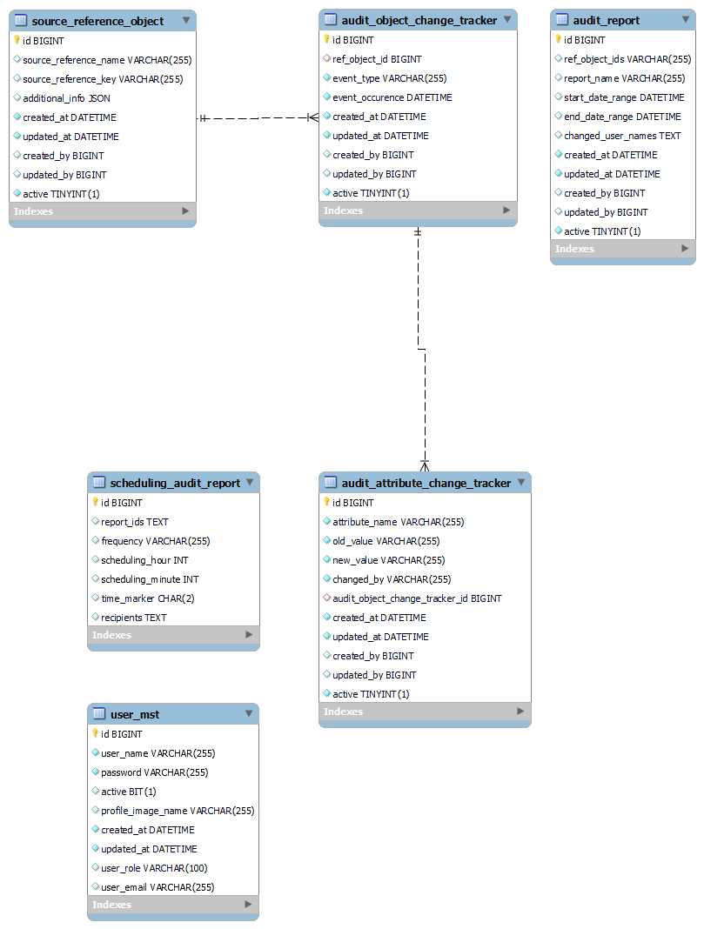

**4. API Design**

**API Documentation URL**:

The API documentation is available at the following Swagger URL:

http://acnproject3.acnovate.local:9090/audit-manager/api/v1/swagger-ui/index.html#/user-controller/findAll

**5. User Interface Design**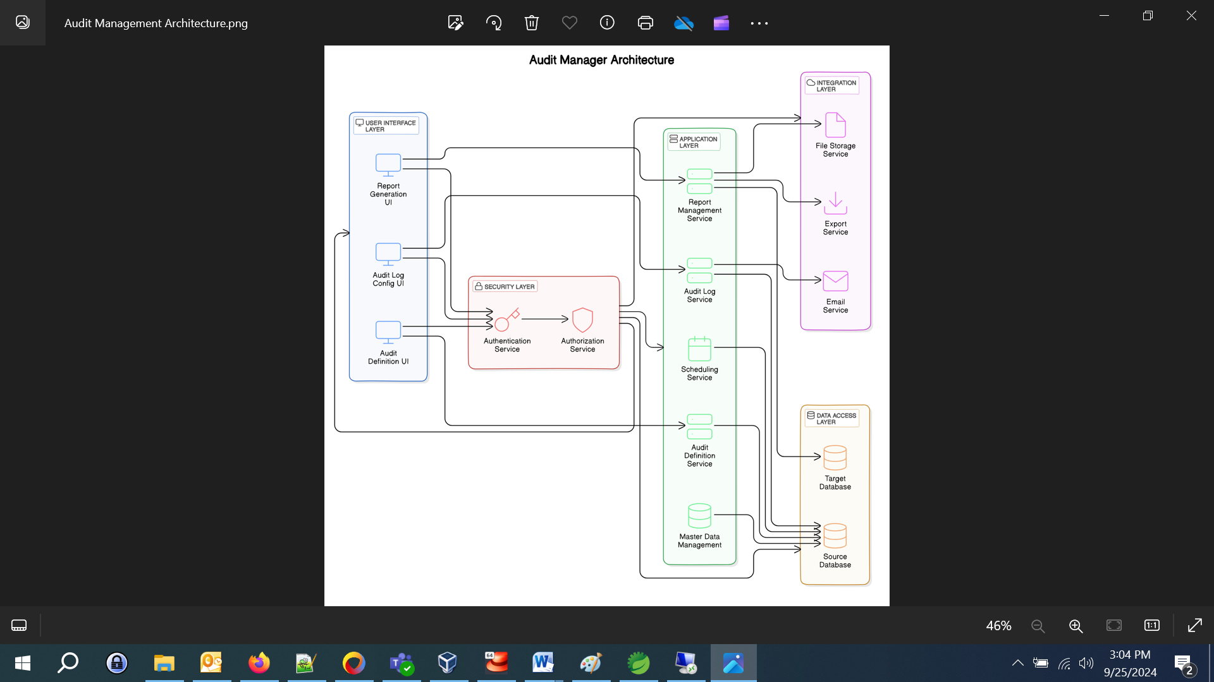

**UI Components:**

1. **Dashboard**

It will show Count of :-

* + Attribute Changes, Object Changes, Changes by user, Event Occurrence’s.
  + Graph of Attribute Changes, Object Changes

1. **Audit Planning Module**
   * Form to create a new Event Type with relative details.
   * List mode to view Event type, Event Occurrence’s.
   * Detailed view of each Object and attribute.
2. **Master Data Management**

* **User Data Management**
  + - To create a new auditor.
    - List mode to view all auditor’s basic details.
    - Auditor can be updated.
* **Audit Preparation**
  + - To create a new audit reference.
    - List mode to view all audit reference details.
    - Audit reference can be updated.

1. **Reporting**
   * Provide Option to generate reports.
   * List mode to view generated reports.
2. **Export Audit Report**
   * Select single or multiple lists, from which auditor wish to export audits.
   * Export the audits as an .XLS file or as a .CSV file.
3. **Scheduling Audit Report**

* The auditor selects the Report Name and sets the schedule (e.g. daily, weekly and monthly).
* System saves the schedule.
* The system sends the generated report to the specified recipients via email